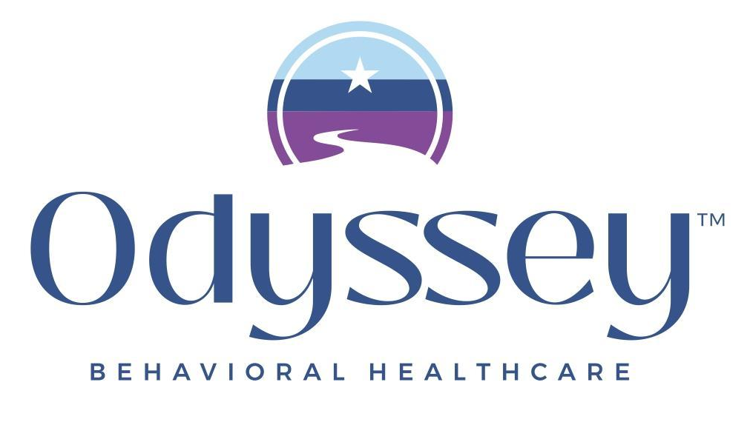
Event Support Request Information
Please complete the information below and attach it to your Marketing Request Form submission so we can best support your event.
Event Name:
Date:
Time:
Location:
Description of the event for promotional purposes:
Is this a CE event?
- Is Odyssey credentialing this event?
- If yes, have you reached out to your supervisor and fill out the CE Webinar Form to set up a CEgo page for registration? If so, please provide the link:
Is this a virtual event?
- If yes, please provide the Zoom or meeting link:
Would you like an Eventbrite page created? (Note: If this is a CEgo or partner CE event, an Eventbrite page is not needed)
- If yes, is there a maximum number of attendees?
Do you need a flyer created for print that includes a QR code?
Would you like this event promoted on social media?
Would you like assistance creating an email invitation or announcement?
- If yes, please send the email distribution list in an Excel file so it can be uploaded to our platform for distribution. If you need assistance with this, please contact your supervisor.

